Saturday, July 11, 2026

Three-Layer Composite Shielding Film for FPC Interface Conducted and Radiated EMI Suppression
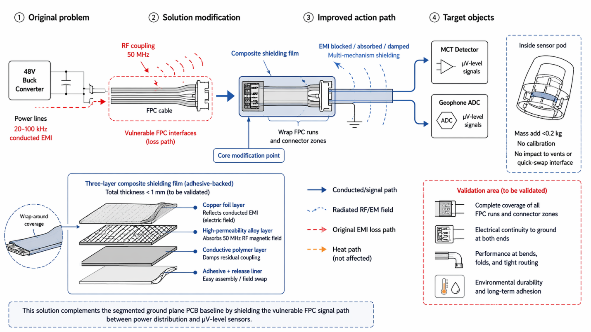

Apply a thin (<1 mm) three-layer composite shielding film to the FPC cable surfaces and connector zones linking the 48V buck converter to the MCT detector and geophone ADC, using an adhesive-backed structure with copper foil (reflects conducted EMI electric field), high magnetic permeability alloy (absorbs 50 MHz GPR radiated RF magnetic field), and conductive polymer (damps residual coupling). This multi-mechanism shielding approach addresses both the 20–100 kHz conducted EMI on power lines and the 50 MHz radiated RF coupling at FPC interfaces.
The composite film adds <0.2 kg mass for the pod's FPC area, requires no calibration, and can be applied during assembly or field swap without impacting thermal venting or quick-swap interface geometry.
This solution complements the segmented ground plane PCB baseline by protecting the vulnerable FPC signal path between power distribution and µV-level sensors, but effectiveness depends on achieving complete coverage of FPC cable runs in the pod's dense sensor layout.
View details
Reference
Anti-interference optimization method, device and equipment for FPC high-performance computing chip interface
Substance-field analysis
Composite Materials (#40), Segmentation (#1), Local Quality (#3)

